St John’s Road  Bishop Monkton  Harrogate  HG3 3QW | 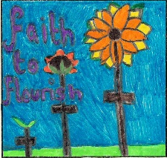

Bishop Monkton CE Primary School

Headteacher- Mrs Sally Cowling M.Ed NPQH Tel/Fax 01765 677583
E Mail: admin@bishopmonkton.n-yorks.sch.uk


26th April 2023
Schools Linking Year 4/5 with Manchester class from
Dixons Primary School, Bradford
Dear Parents,

We are now well into our Link School Project. We have exchanges identity maps and bunting to introduce ourselves and before Easter we had a fabulous TEAMS call to meet our new friends visually. Whilst recapping on all our Spring Term learning, the children said how much they have enjoyed our link and how they wish they could do more.

Just as a reminder, here are the 4 key questions that drive this project:

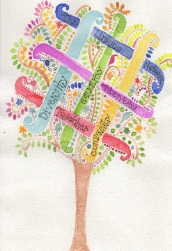
- Who am I? - looking at all the things that make us who we are and form a part of our identity.
- Who are we? - looking at the similarities and differences we may share with others and thinking about the different things that might make up the identity of others.
- Where do we live? - looking at the community we live in and the communities in which others live in as well as celebrating all the things we share on planet Earth.
- How do we all live together? - looking at how we can live, play, and work together so that everyone is treated fairly and is happy.


In our next phase we have 2 very exciting dates.
Thursday 25th May – we shall be hosting our friends from Dixons Primary here. It will be such a fun day.
Wednesday 14th June – we shall be visiting Dixons Primary. Myself, Mrs Cairns, Mrs McDonald and Miss Brown will be accompanying and we will be travelling by Atkinson’s Coach Travel. We shall leave after register and return before the end of the school day. The children will need a packed lunch. The cost of the travel is £12.07 per child but we are asking for just £10 per child to be paid through Parent Pay.

Thank you for your support in making this valuable project happen for your child/ren.
Best wishes,
Debbie Handslip and Kay Cairns


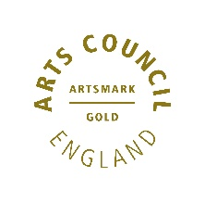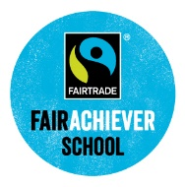

Faith to Flourish

