St John’s Road  Bishop Monkton  Harrogate  HG3 3QW | 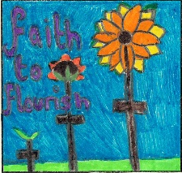

Bishop Monkton CE Primary School

Headteacher- Mrs Sally Cowling M.Ed NPQH Tel/Fax 01765 677583
E Mail: admin@bishopmonkton.n-yorks.sch.uk


6th December 2022
Schools Linking Year 4/5
Dear Parents/Carers,

Our Year 4/5 children are taking part in an extra special School Linking Project. We will be linking with Dixons Music Primary, Bradford. We are looking forward to the virtual learning we will share with children from our link class from within the classroom.

As part of this project, we are going to explore the following key questions:

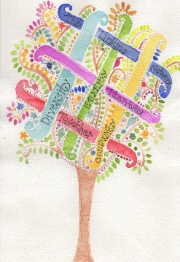
- Who am I? - looking at all the things that make us who we are and form a part of our identity.
- Who are we? - looking at the similarities and differences we may share with others and thinking about the different things that might make up the identity of others.
- Where do we live? - looking at the community we live in and the communities in which others live in as well as celebrating all the things we share on planet Earth.
- How do we all live together? - looking at how we can live, play, and work together so that everyone is treated fairly and is happy.
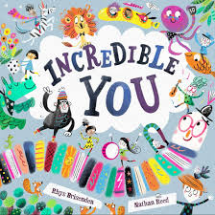
We will be thinking carefully about these questions at different points in the year by:
- Discussing our ideas and asking each other questions
- Creating thoughtful curriculum work to share – poetry, art, stories, letters..
- Enjoying storyteller sessions, theatre experience, learning some sign language and so much more.

Over the course of the year, we will exchange photographs and videos of ourselves and our work and take part in shared online lessons so we can see the exciting things that are happening through our linking work in both schools.

I am sure you will agree that this is a great project for our children to be involved in and we look forward to sharing our linking work with you later this year. If you have any questions about this or the linking work in general, then please do come and speak to either Mrs Handslip or Mrs Cairns.

Thank you for your support.
Best wishes,
Debbie Handslip and Kay Cairns


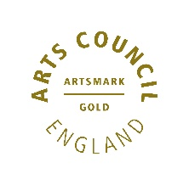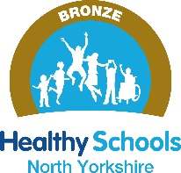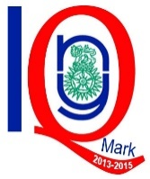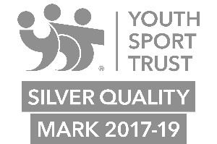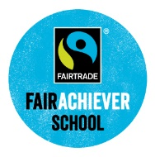

Faith to Flourish

